Table Storage

Create a resource Group

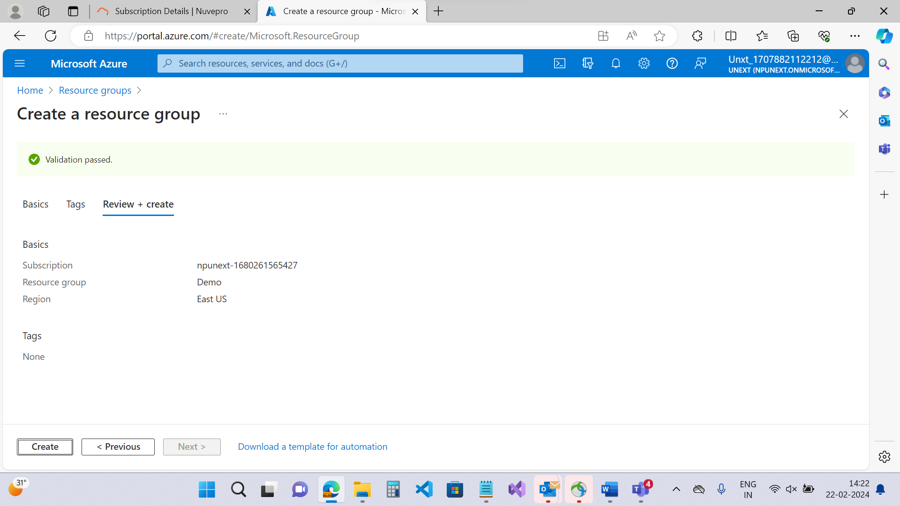

Create a Storage Account

Storagetables

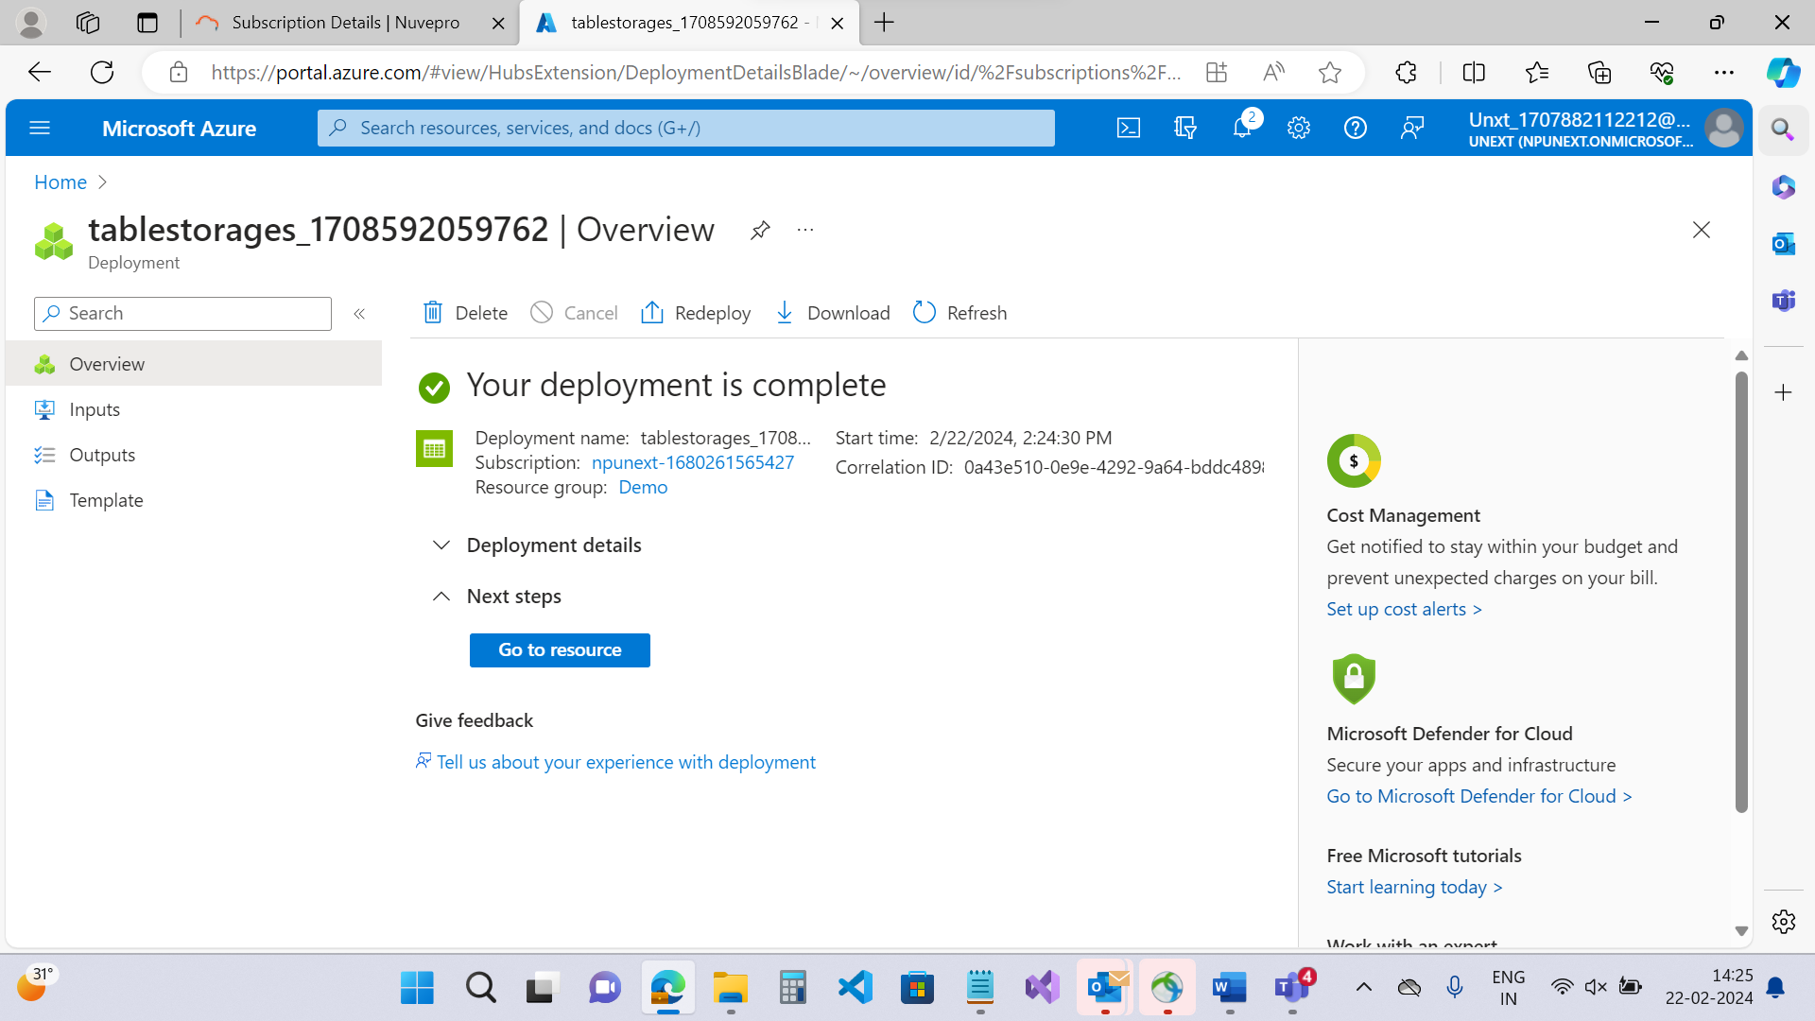

Inside of storagetables looks for tables and create a table

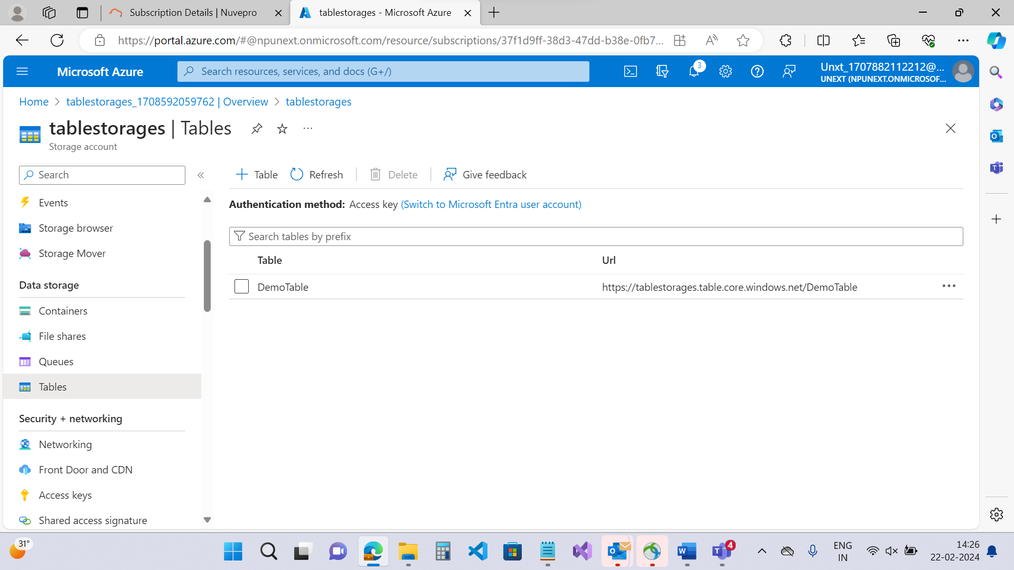

Create a SAS token

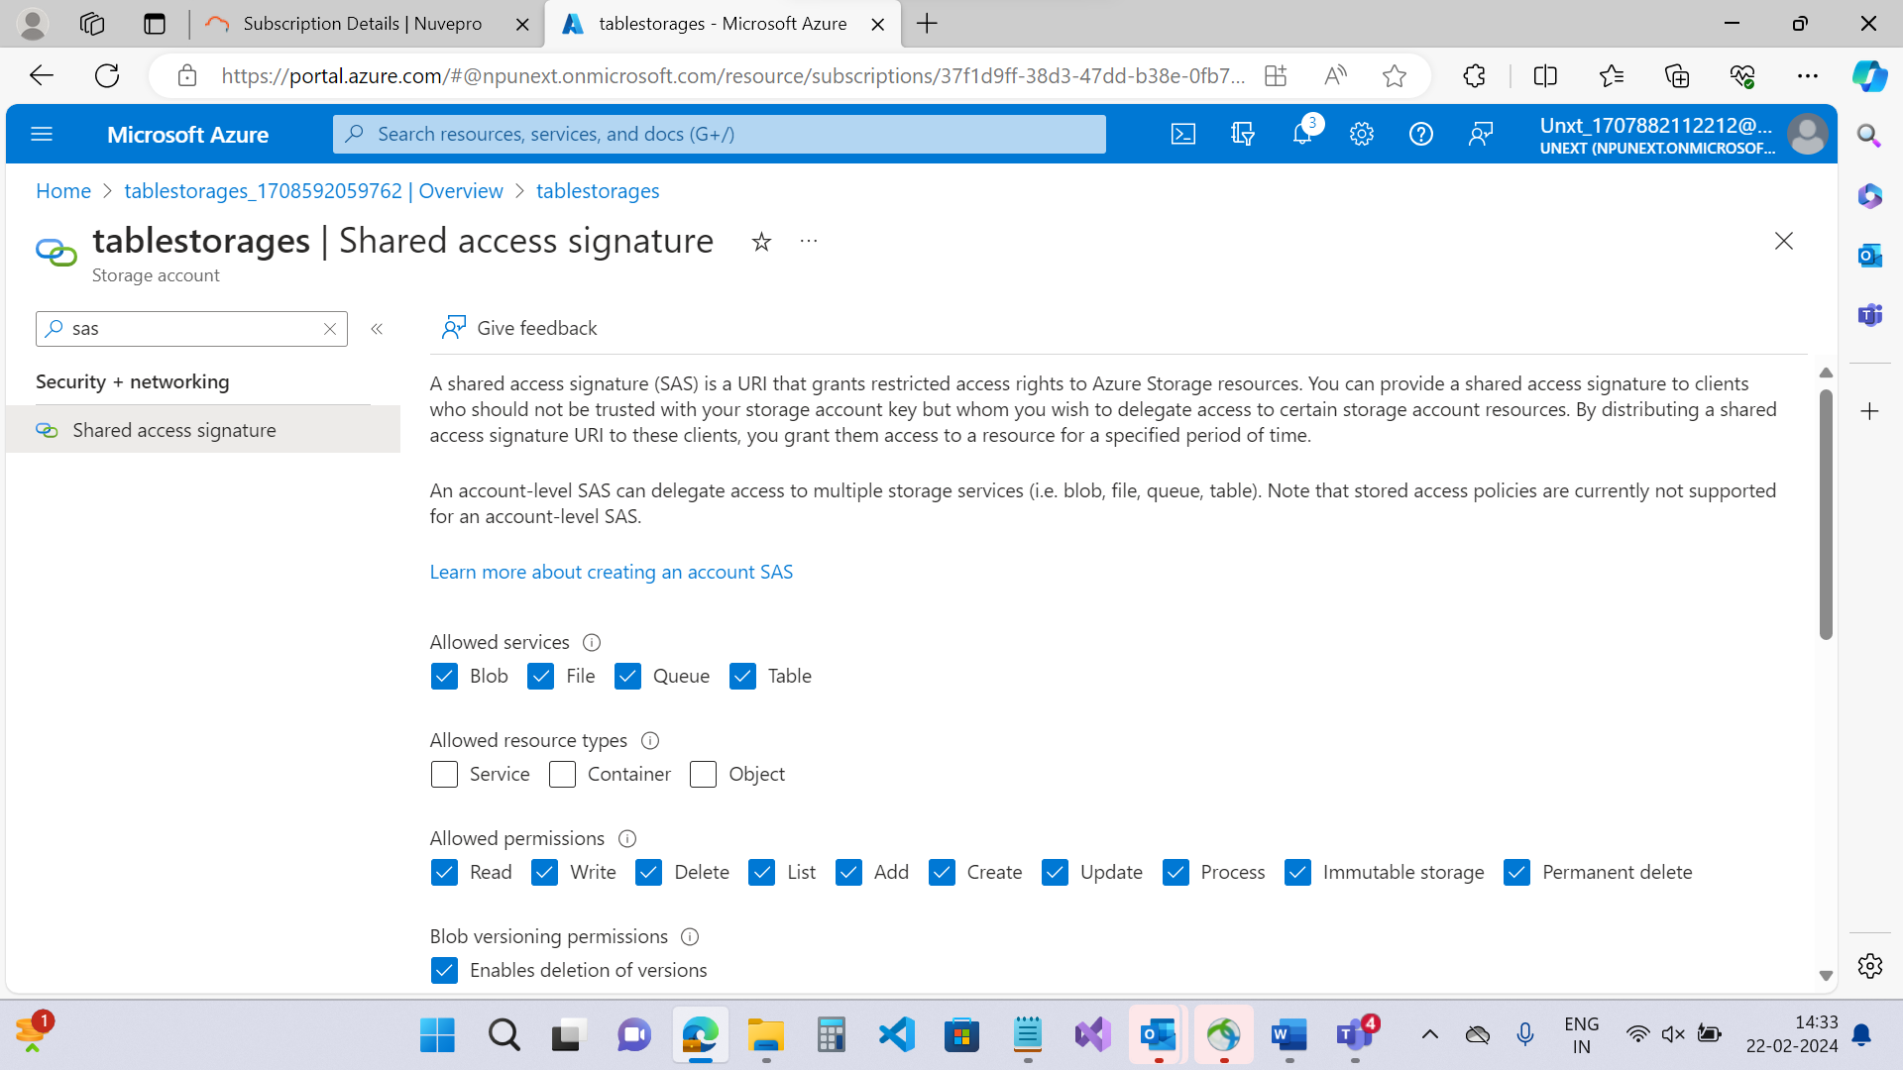

Got the connection string

Open Visual Studio 🡪 Install Azure.Data.Tables

TableClient will accept the table and the connection string and it coordinates the table

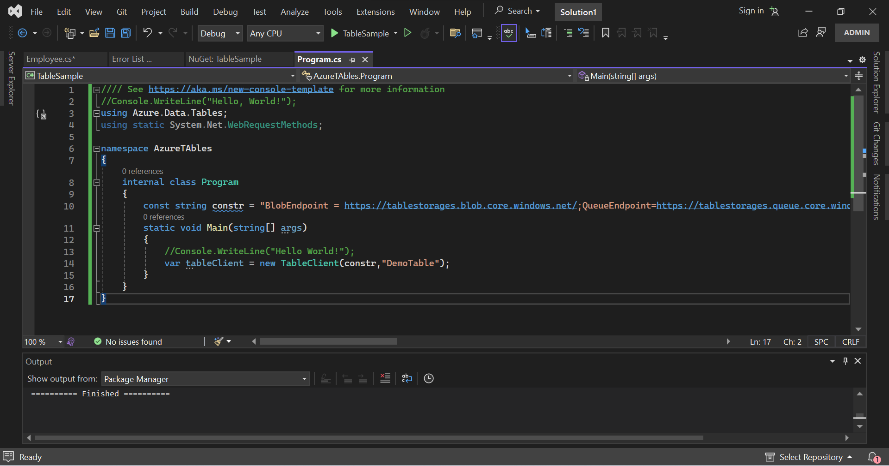

Add A new Class

ITableEntity is predefined Interface that is part of Azure.Data.Tables

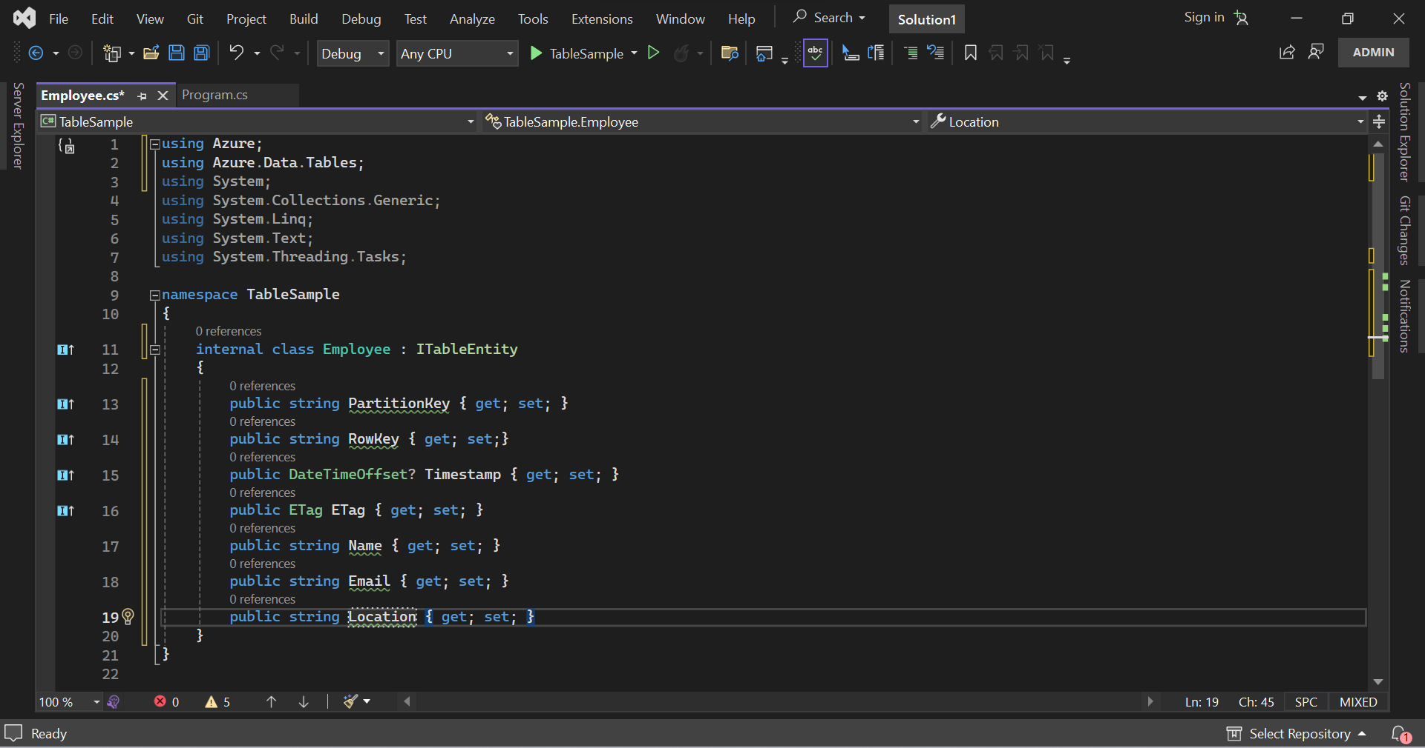

Go to 🡪 Program.cs

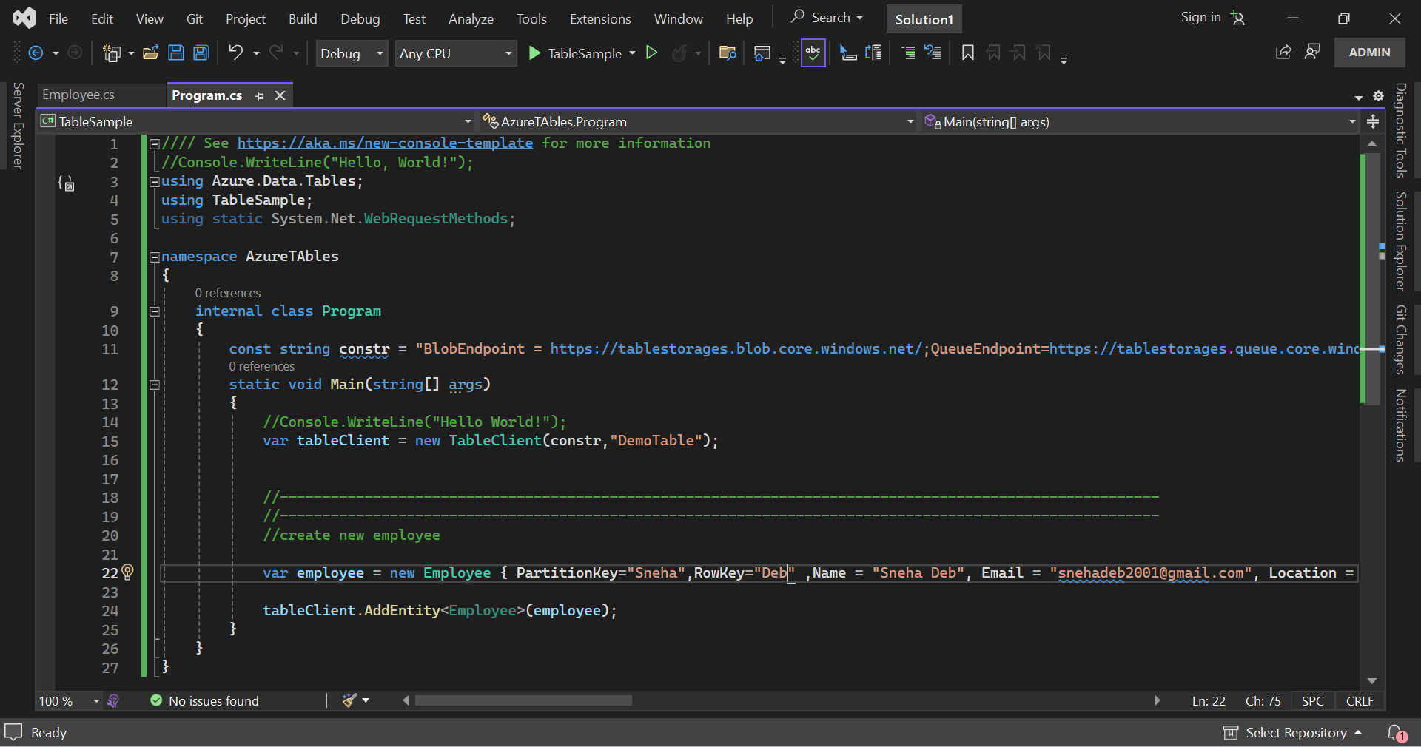

Go to Storage Browser🡪Tables🡪Your Table🡪

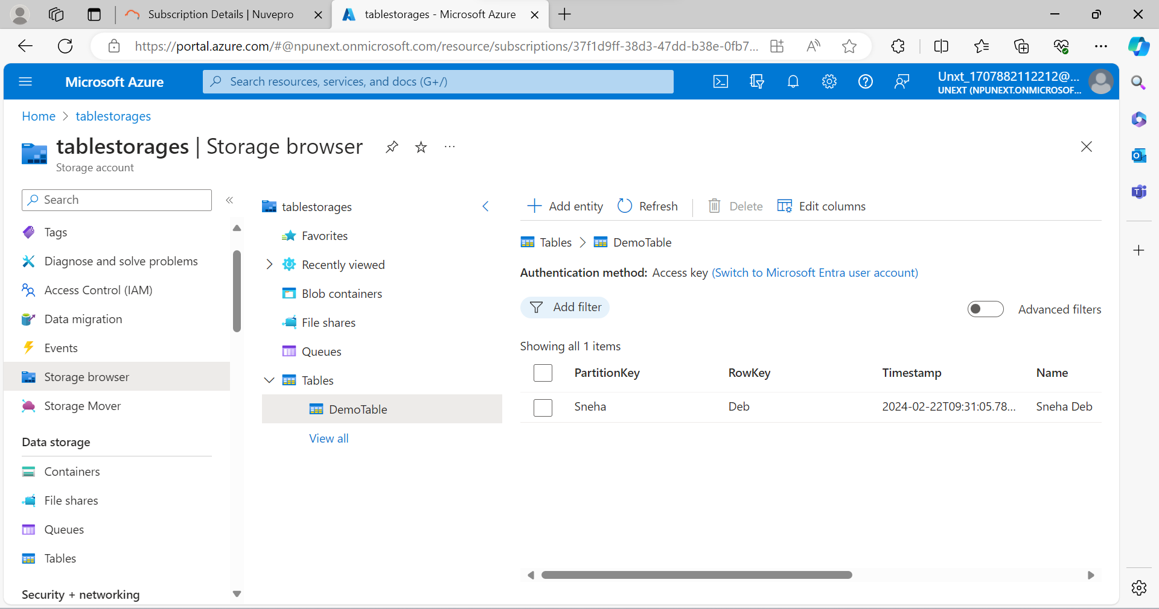

We can edit Also

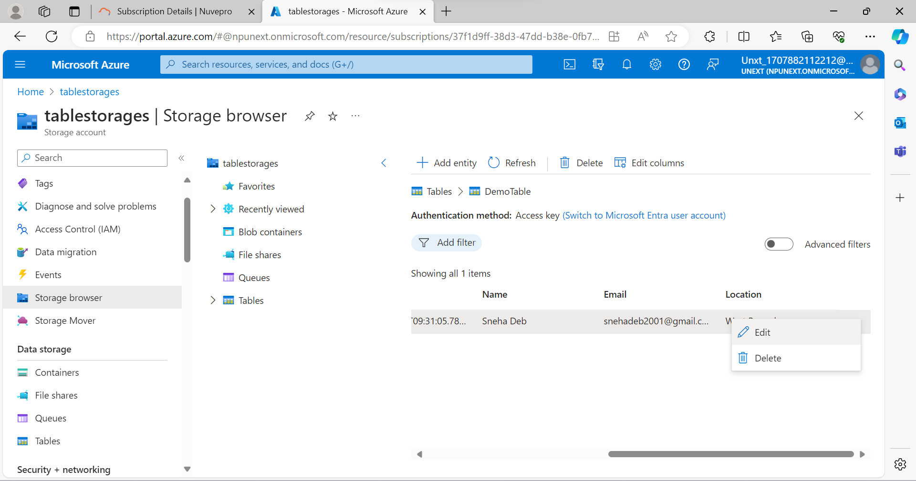

Get by address and update address

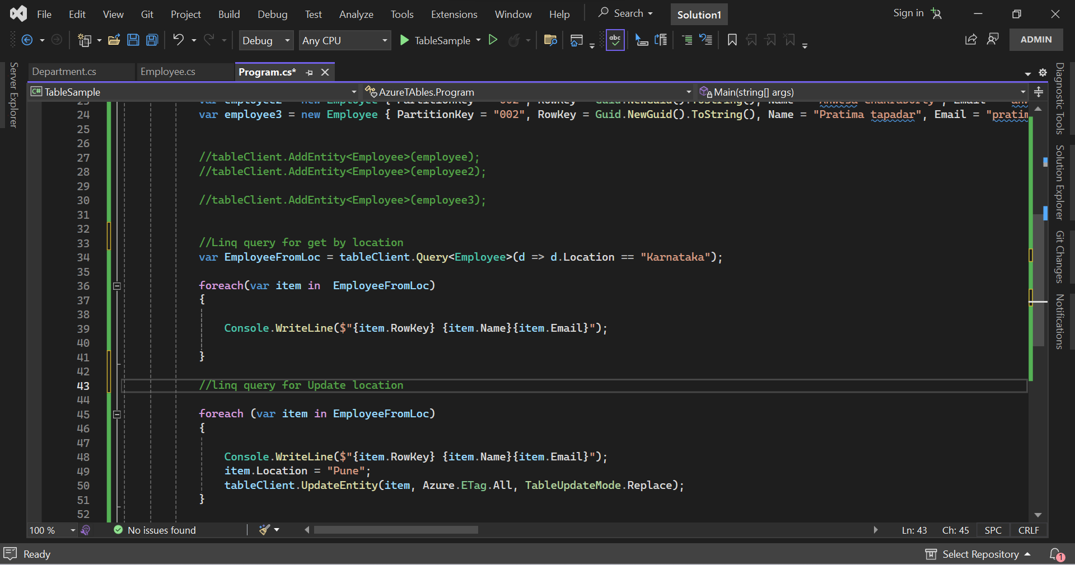

Queue Storage

Azure queues is a storage service that stores messages and delivers the messages as first in first serve method.

Go to Storage🡪Create a Queue

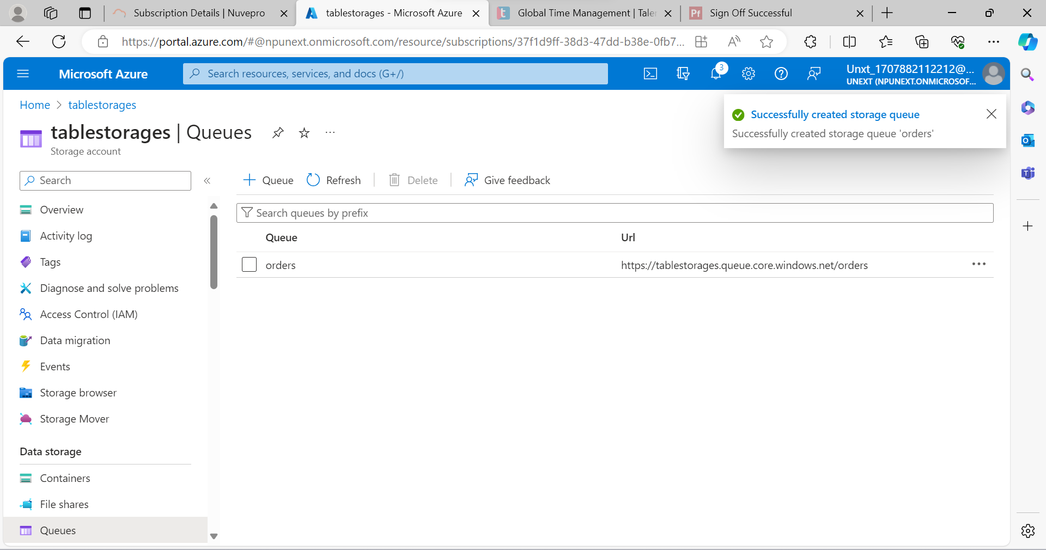

Install NuGet Packages

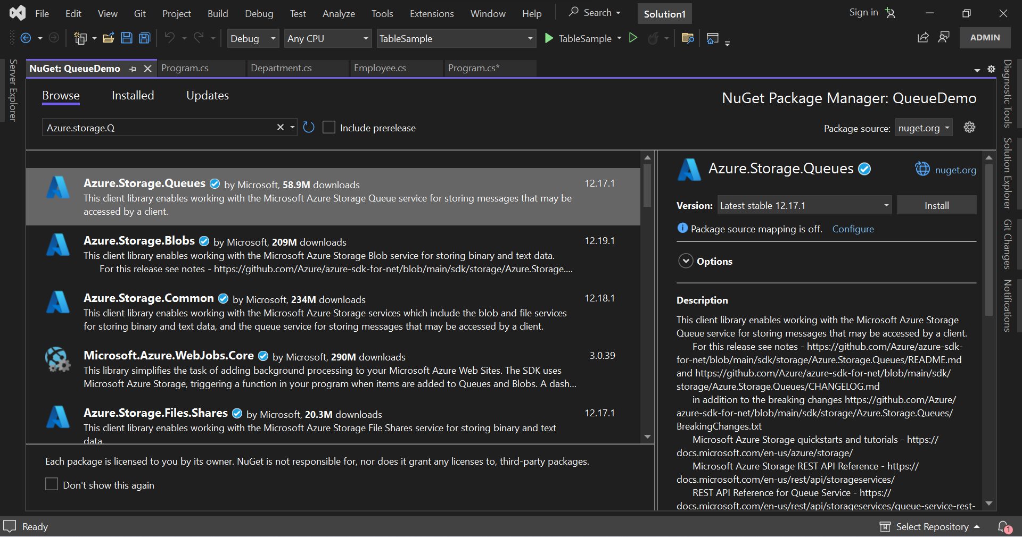

Generate SAS



